28.43: a) The magnetic field from the solenoid alone is:

(i)
(ii) But 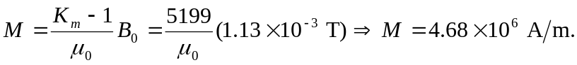
(iii)

b)
